**Week#11 – ARP**

**Learning objectives:**

A. Understand

* + *Address Resolution Protocol*
  + *MAC table updating in Ethernet Switch*

1. Learn
   * IP headers

**Part A has 2 parts**

1. **Simple switch based network.**
2. **Network with one routers.**

**1.Simple switch based network.**

Topology

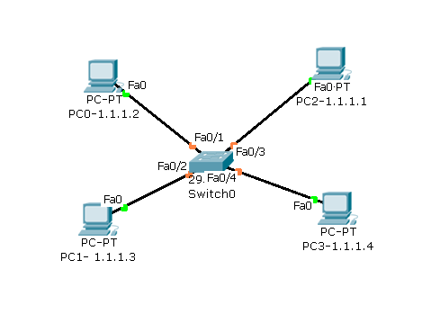

Use REAL MODE

|  |  |  |  |
| --- | --- | --- | --- |
|  | Action | What to observe? | Comments/ Questions /Reasons |
| 1 | Create the topology as shown |  |  |
| 2 | Configure the IP addresses of all hosts as per the addresses given in the topology |  |  |
| 3 | Before PINGng ,  Using inspection tool ( lens like icon in the the right corner) | Check ARP table of all PCs | ?? |
|  |  | Check MAC table of Switch | ?? |
|  | PING from PC0 to PC1 | Check ARP table of PC0 & PC1 | **Ans :** |
|  |  | Check MAC table of Switch | **Ans :** |
|  | PING from PC2 to PC3 | Check ARP table of PC2 & PC3 | **Ans :** |
|  |  | Check MAC table of Switch | **Ans :** |
|  | PING between all the PCs | Check ARP table of PC0 & PC1 | **Ans :** |
|  |  | Check MAC table of Switch | **Ans :** |
|  |  |  | What is the inference after all these steps , about ARP ?  **Ans :** |
|  |  |  |  |

**Repeat the experiment in Simulation mode and observe how ARP works.**

1. Select real time mode and click **‘power cycle devices’** on the task bar, so that it resets the previous data.
2. Wait until the green dots occur at every equipment.
3. Now select **‘Simulation’** mode.
4. Ping from PC0 and PC1( using Simple PDU ).
5. Click **auto-capture and play** mode.
6. You will observe the following
7. *Movement of packets*
8. *Event list displays series of events and protocols on a timeline.*
9. Wait until you get the **‘successful’** status.
10. Click again **auto-capture and play** to stop simulation.
11. Start analyzing the ARP protocol watching the series of events listed in the **event Window**

**Note down the protocols listed in the event list window ?**

**Ans :**

Select only ARP filtering all other protocols and answer the following questions.

**10.1.Analyse ARP PDU**

|  |  |  |
| --- | --- | --- |
| *at device* | *What needs to be written in your observation book* |  |
| PC0 | Source IP Address | **Ans :** |
|  | Destination IP Address | **Ans :** |
|  | Source MAC address | **Ans :** |
|  | Target MAC address | **Ans :** |
| PC1 |  |  |
| Inbound PDU |  |  |
|  | Target MAC address | **Ans :** |
|  | OPCODE | **Ans :** |
|  | Target IP address | **Ans:** |
| Outbound PDU | Target MAC address | **Ans :** |
|  | Target IP address | **Ans :** |
|  | OPCODE | **Ans :** |
|  | Protocol type | **Ans :** |

**Analyze how ARP works**

**2.Network with one router**

**When two hosts in the same subnet communicate**

**[Use Real time mode ]**

Step#1. Set up the network topology as shown below and configure IP addresses and gateway addresses.

Step#2. Check the ARP table of PC0, PC1 & PC2, using inspection tool.

Step#3. Ping from PC0 to PC1.

Step#4. Check the ARP table of PC0 & ARP table of the Router.

***Write down your observations***

***Ans***

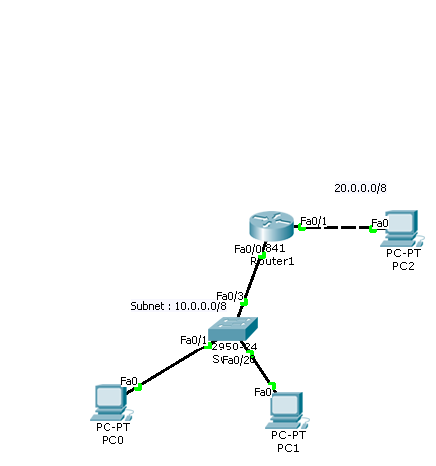

**2.2. When two hosts in the different subnets communicate**

**[Use Real time mode ]**

Step#1. Click power cycle devices.

Step#2. Check the ARP table of PC0, PC1 & PC2, using inspection tool.

Step#3. Ping from PC0 to PC2.

Step#4. Check the ARP table of PC0 & ARP table of the Router.

***Write down your observations.***

**2.3. Repeat these two experiments in Simulation mode and observe how ARP works.**

***Write down the contents of any sample ARP PDU (with opcode 1 and 2)***